# **CNN Backpropagation Part 2 | How Backpropagation works on Convolution, Maxpooling and Flatten Layers**

### **Detailed Notes on Backpropagation in CNNs**

This document details the process of backpropagation within Convolutional Neural Networks (CNNs), focusing on the **Flatten, Max Pooling, and Convolution layers**. Understanding this mathematical process, though not always requiring manual coding, significantly enhances comprehension of your code. It is recommended to review this information multiple times and use a copy and pen to follow along due to the complex mathematics involved.

It's helpful to have seen the previous part of this video series, as some concepts and calculations are built upon.

#### **1. Basic CNN Architecture & Forward Propagation Overview**

The basic CNN architecture discussed involves a series of operations:

* An **input image (X)** is convolved with a **filter (W1)** and **bias (B1)** to produce **Z1**.
* A **ReLU activation function** is applied to Z1, yielding **A1**.
* **Max Pooling** is performed on A1, resulting in a **reduced feature map (P1)**.
* P1 is then **Flattened** to create **F**.
* F is passed to a **single output layer** with a **sigmoid activation function**, producing the **predicted output (Y_hat)**.
* Finally, a **loss (L)** is calculated based on Y_hat and the true label Y.

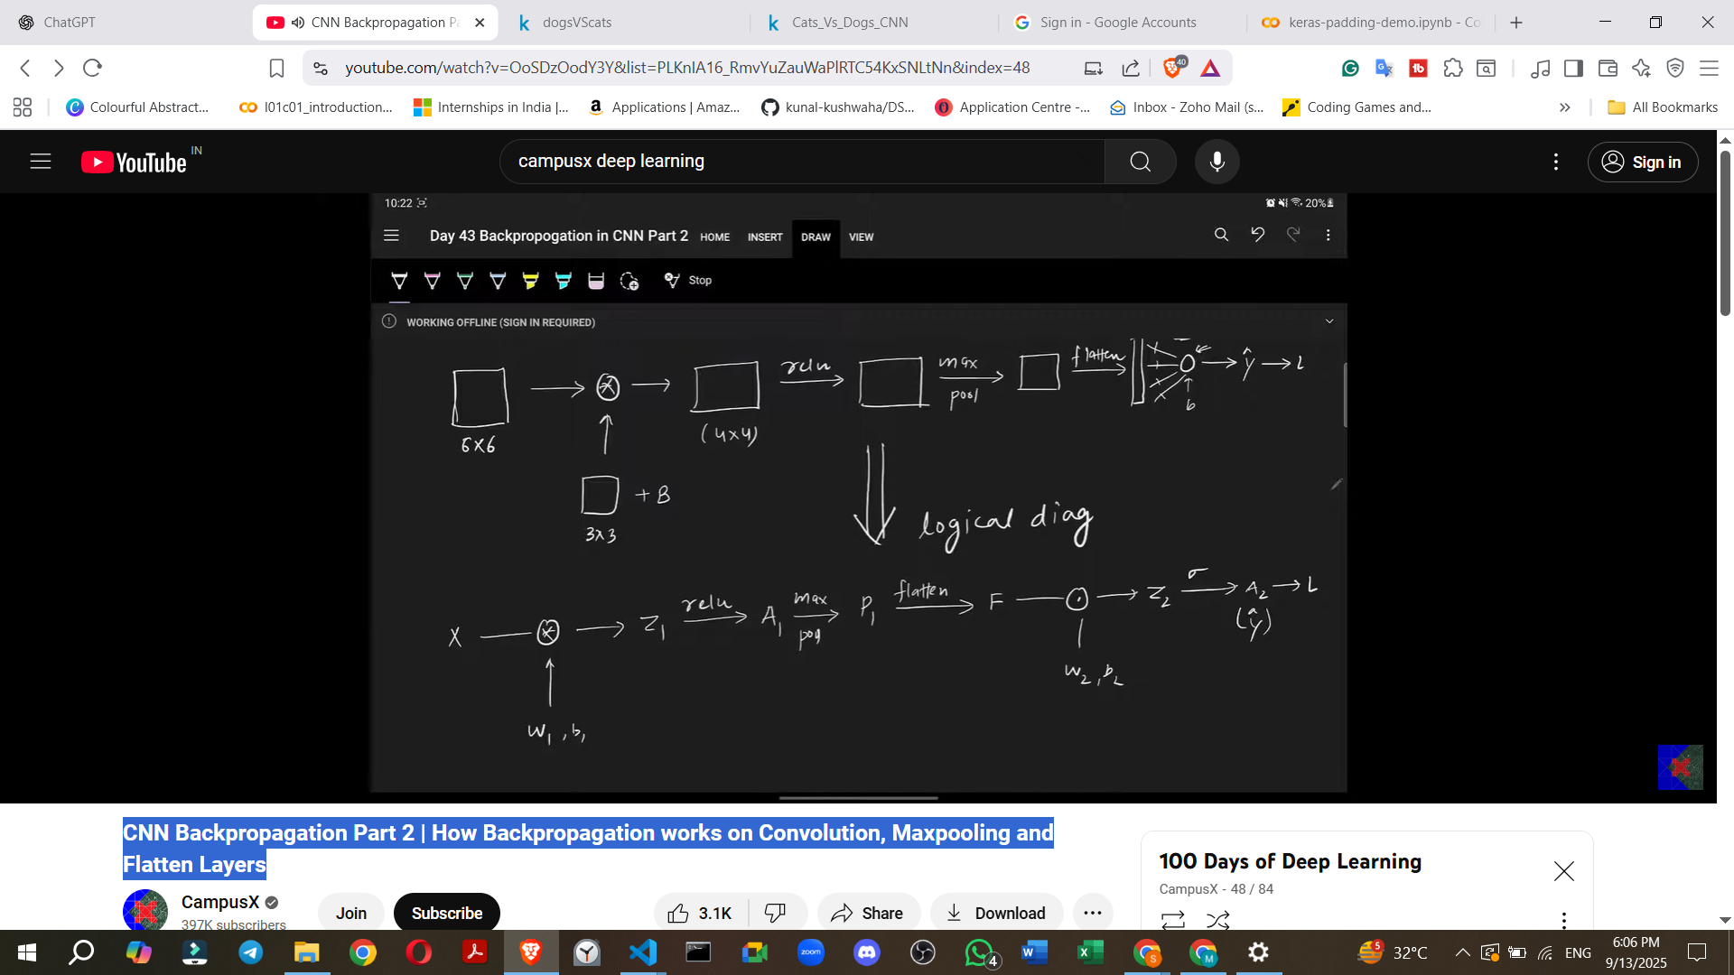

**Forward Propagation Equations:**

* **Z1** = Convolution (X, W1) + B1
* **A1** = ReLU(Z1)
* **P1** = Max Pooling(A1)
* **F** = Flatten(P1)
* **Z2** = F * W2 + B2 (for the fully connected layer, where W2 and B2 are weights and biases)
* **A2 (Y_hat)** = Sigmoid(Z2)
* **L** = -Y * log(A2) - (1-Y) * log(1-A2) (Binary Cross-Entropy Loss)

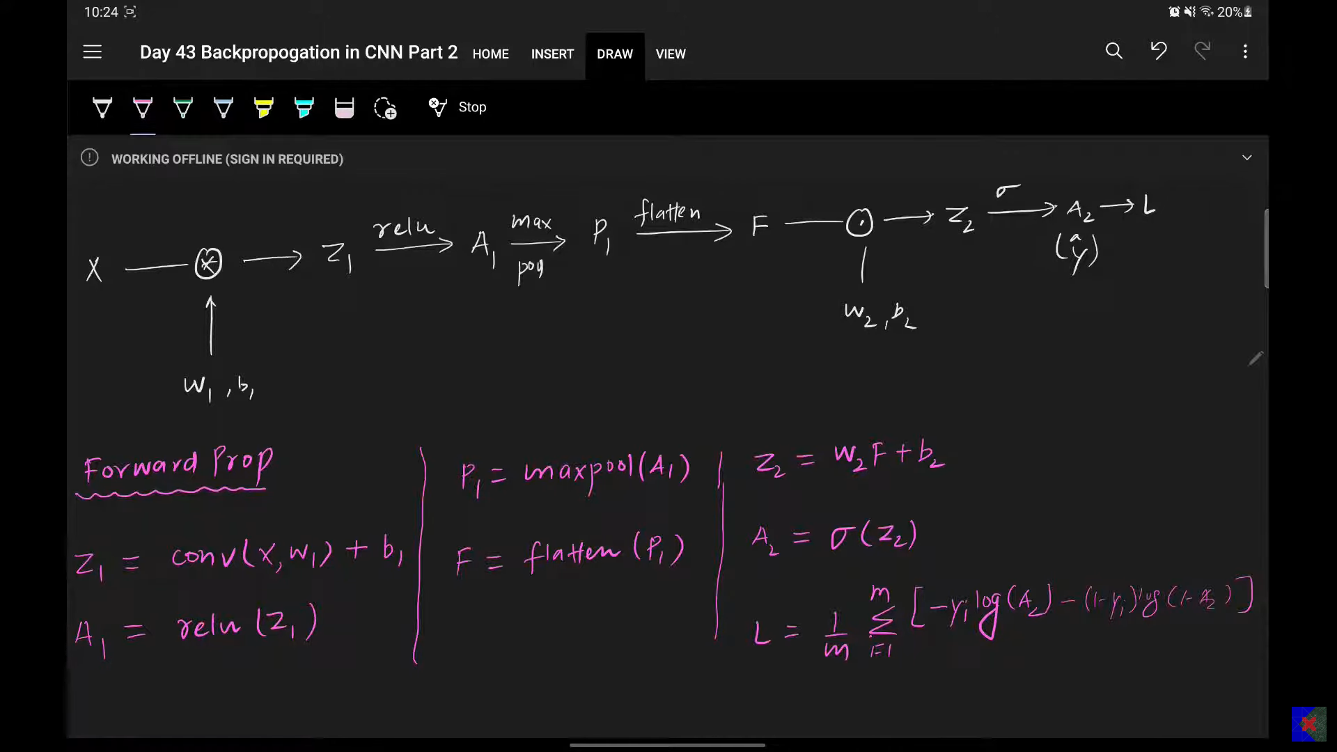

#### **2. Goal of Backpropagation**

The primary goal of backpropagation in this context is to **calculate the gradients** of the loss with respect to the trainable parameters (weights and biases) of the convolutional layer: **W1 and B1**. These gradients are then used to update the parameters via **gradient descent**:

* W1_new = W1 - Learning_Rate * (del L / del W1)
* B1_new = B1 - Learning_Rate * (del L / del B1)

To achieve this, the **chain rule** is applied to derive the necessary partial derivatives. For example, to find del L / del W1, the chain rule would be: del L / del W1 = (del L / del A2) * (del A2 / del Z2) * (del Z2 / del F) * (del F / del P1) * (del P1 / del A1) * (del A1 / del Z1) * (del Z1 / del W1).

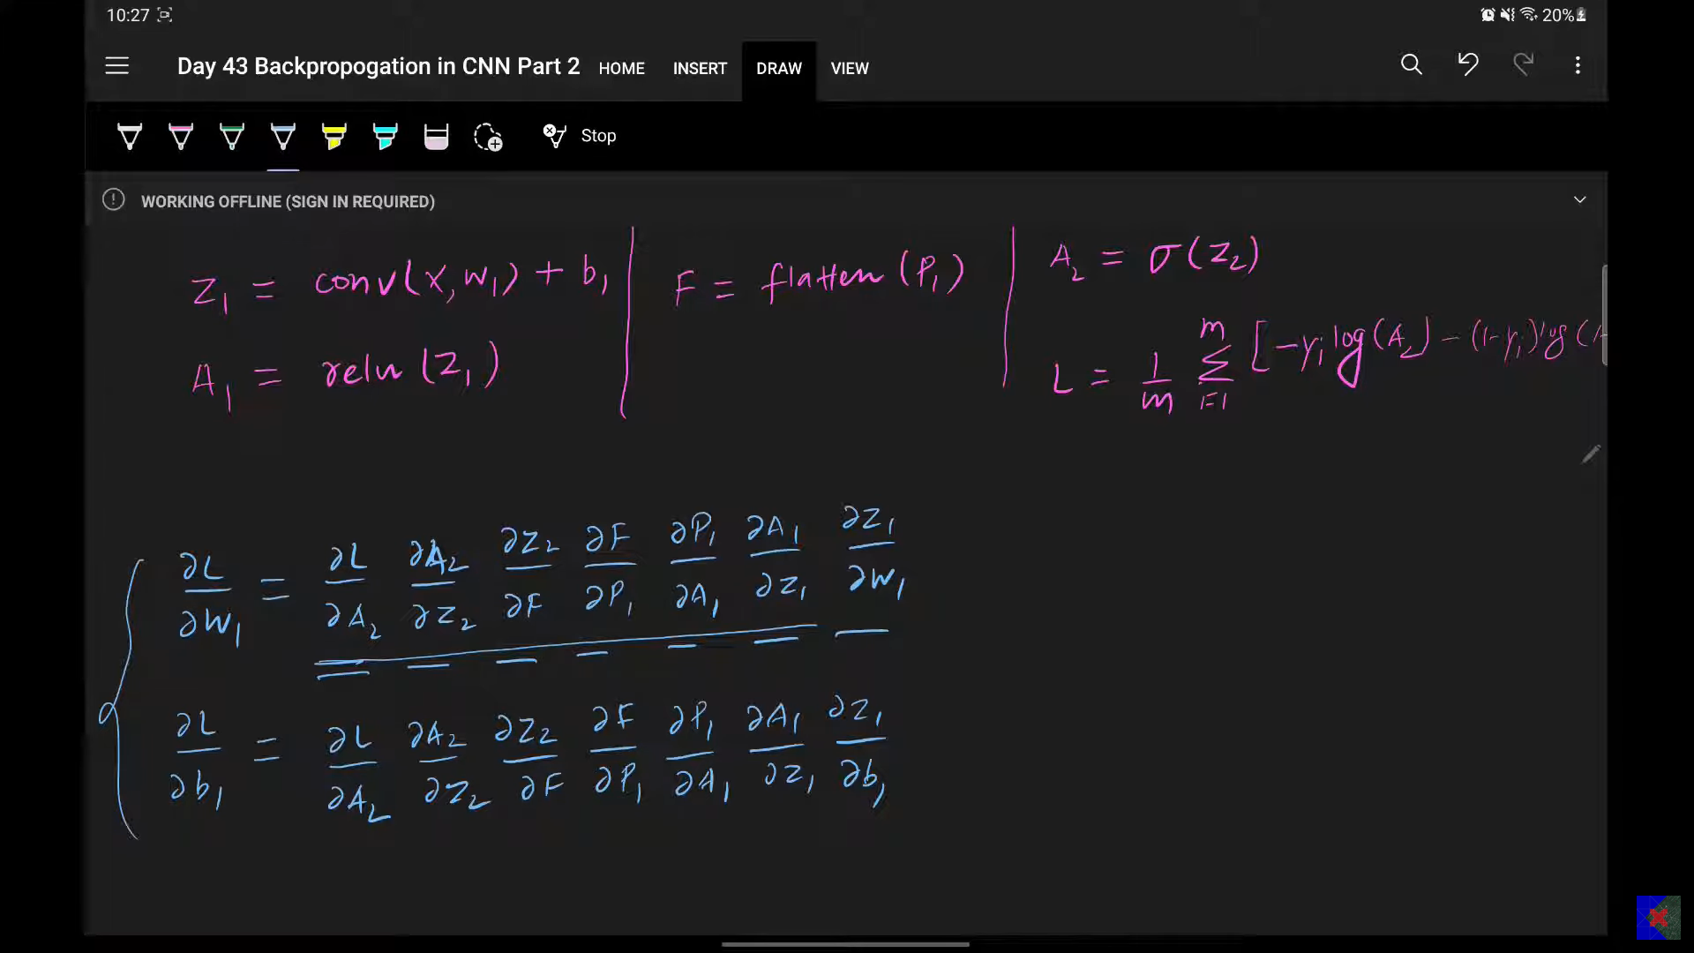

Similarly, for del L / del B1, the chain rule would include all terms up to del Z1, followed by (del Z1 / del B1).

**Previously Calculated Derivatives (from Fully Connected Layer):** The product of (del L / del A2) * (del A2 / del Z2) for the fully connected layer was already calculated in the previous video and found to be A2 - Y (where Y is the target label).

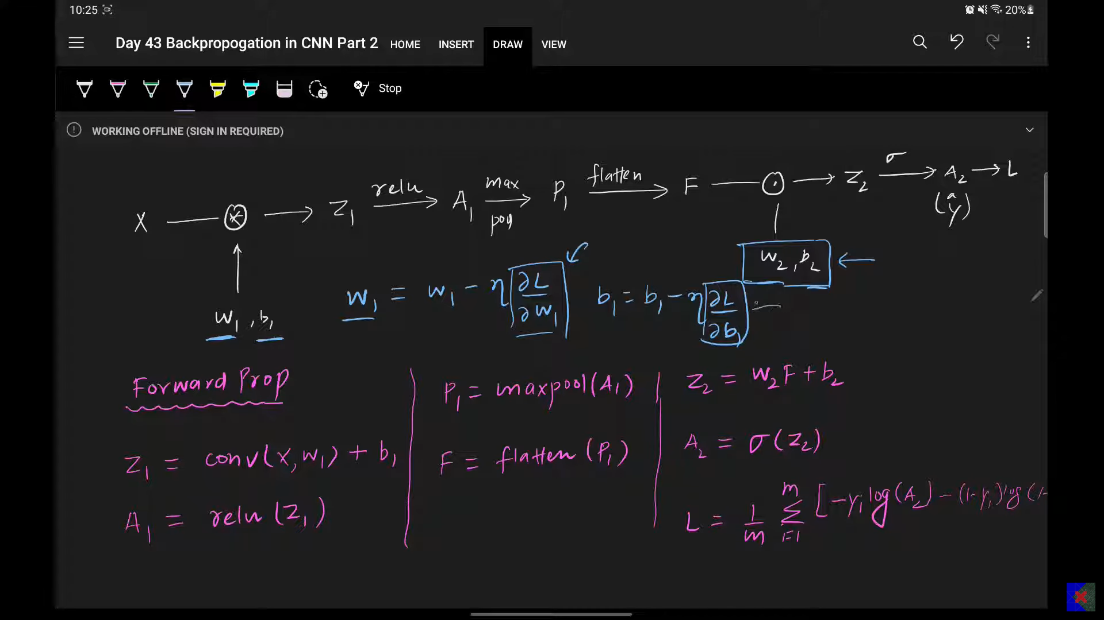

#### **3. Backpropagation on the Flatten Layer**

The Flatten layer **does not have any trainable parameters**. Therefore, backpropagation here does not involve calculating gradients for weights or biases in the conventional sense.

* **Forward Operation:** The Flatten layer converts a multi-dimensional tensor (e.g., 2x2) into a one-dimensional vector (e.g., 4x1).
* **Backward Operation:** During backpropagation, the Flatten layer's reverse operation is simply to **reshape the incoming gradient** (which is a 1D vector) back into its original multi-dimensional shape (e.g., 4x1 back to 2x2). This means del F (the gradient coming into the Flatten layer) is reshaped to del P1.

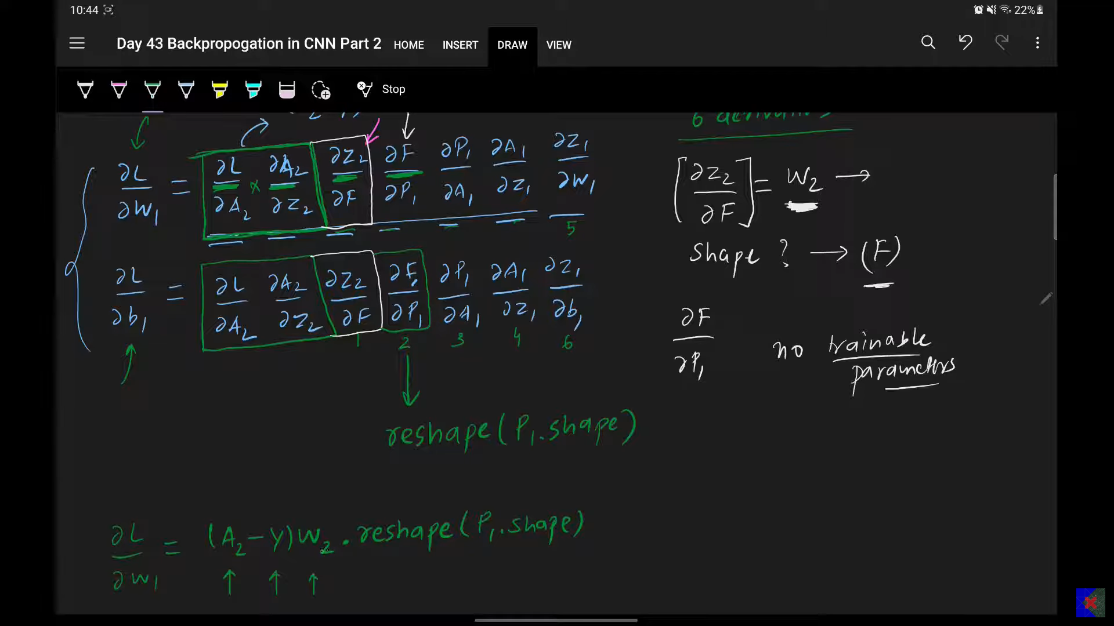

* **Question:** Since there are no trainable parameters, what is the purpose of "backpropagating" through the Flatten layer?
* **Answer:** Its purpose is to correctly reshape the gradients so they match the dimensions of the preceding Max Pooling layer, allowing the chain rule to continue.

#### **4. Backpropagation on the Max Pooling Layer**

Similar to the Flatten layer, the Max Pooling layer **does not have any trainable parameters**. Thus, backpropagation here also involves a reverse operation rather than direct differentiation for parameter updates.

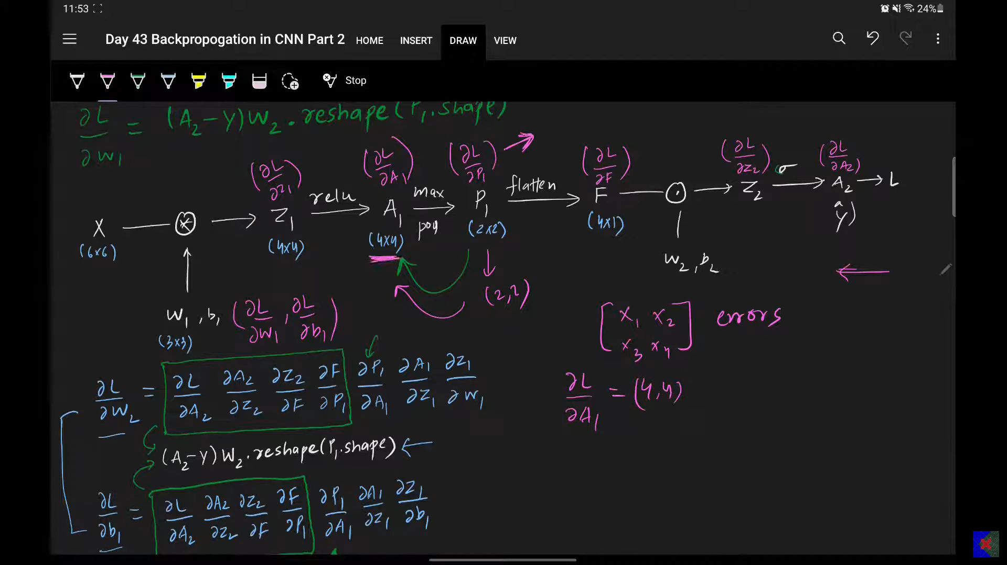

**Forward Operation Example:** If you have a 4x4 matrix and apply 2x2 max pooling (with a stride of 2), you get a 2x2 output. For example, from a 4x4 matrix:  
  
 [,

,

,

]

* Max pooling extracts the maximum value from each 2x2 window:  
  + Window 1: max(1,2,5,6) = 6
  + Window 2: max(3,4,7,8) = 8
  + Window 3: max(9,10,13,14) = 14
  + Window 4: max(11,12,15,16) = 16 This results in a 2x2 output:

[[ 6, 8],

]

* **Backward Operation:** When backpropagating through Max Pooling, you need to convert the 2x2 incoming gradient (e.g., X1, X2, X3, X4) back to a 4x4 matrix, del A1.  
  + **The key insight:** Only the maximum value in each pooling window contributes to the forward pass and thus to the loss. The other values in the window (those that were not the maximum) have **no contribution** to the loss calculation.
  + Therefore, the gradient (del L / del P1) (e.g., X1, X2, X3, X4 in a 2x2 matrix) is **placed back into the original positions where the maximum values were located** in the A1 matrix (before max pooling). All other positions are set to zero.

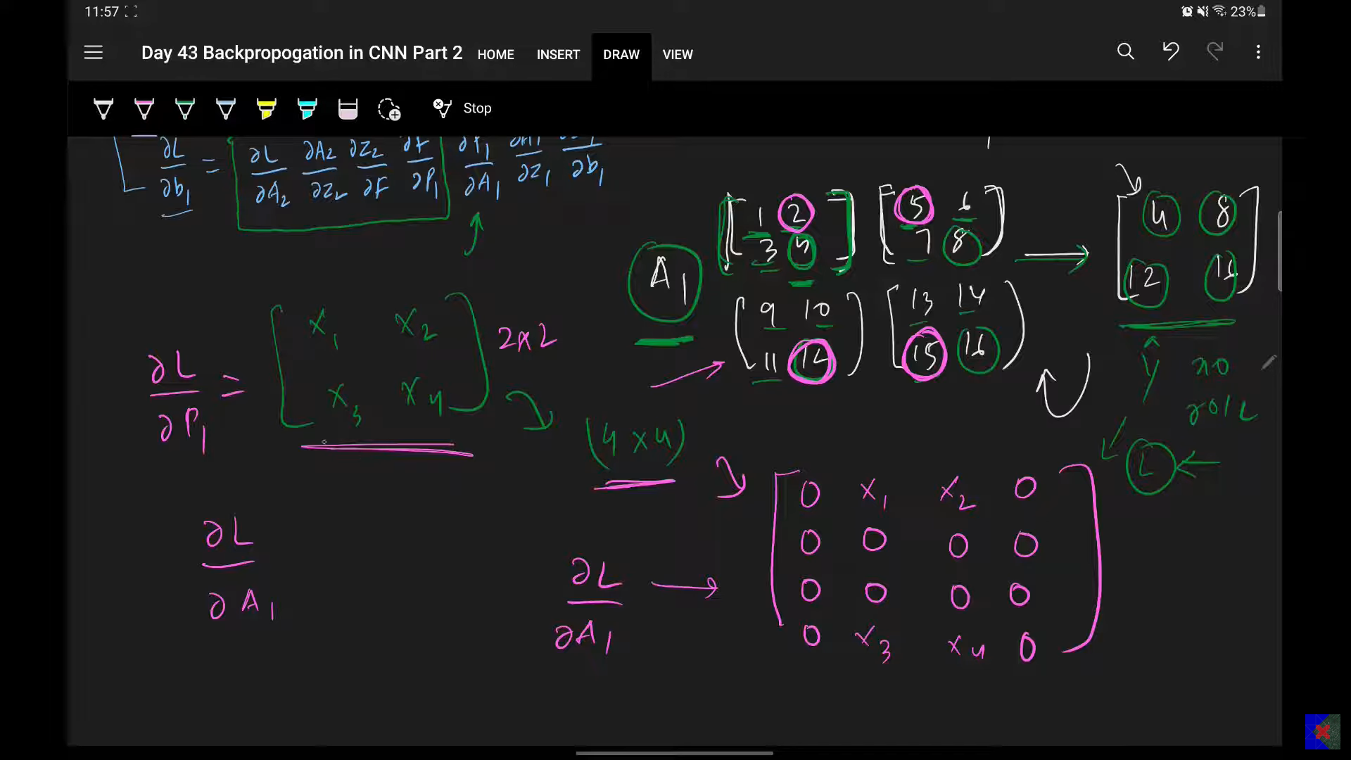

**Example (reversing the above):** If del L / del P1 is [[X1, X2], [X3, X4]], and the original A1 matrix had 6, 8, 14, 16 as maximums at specific positions, the del A1 matrix would look like:  
 [, // 1,2,5 were not max

[0, X1, 0, X2], // 6,8 were max

, // 9,10,13 were not max

[0, X3, 0, X4]] // 14,16 were max

* + (This is a conceptual example, actual positions would depend on the original max locations).
* **Mathematical Notation:** del L / del A1 (x,y) = del L / del P1 (m,n) if A1(x,y) was the maximum in its m,n pooling window, otherwise del L / del A1 (x,y) = 0.
* 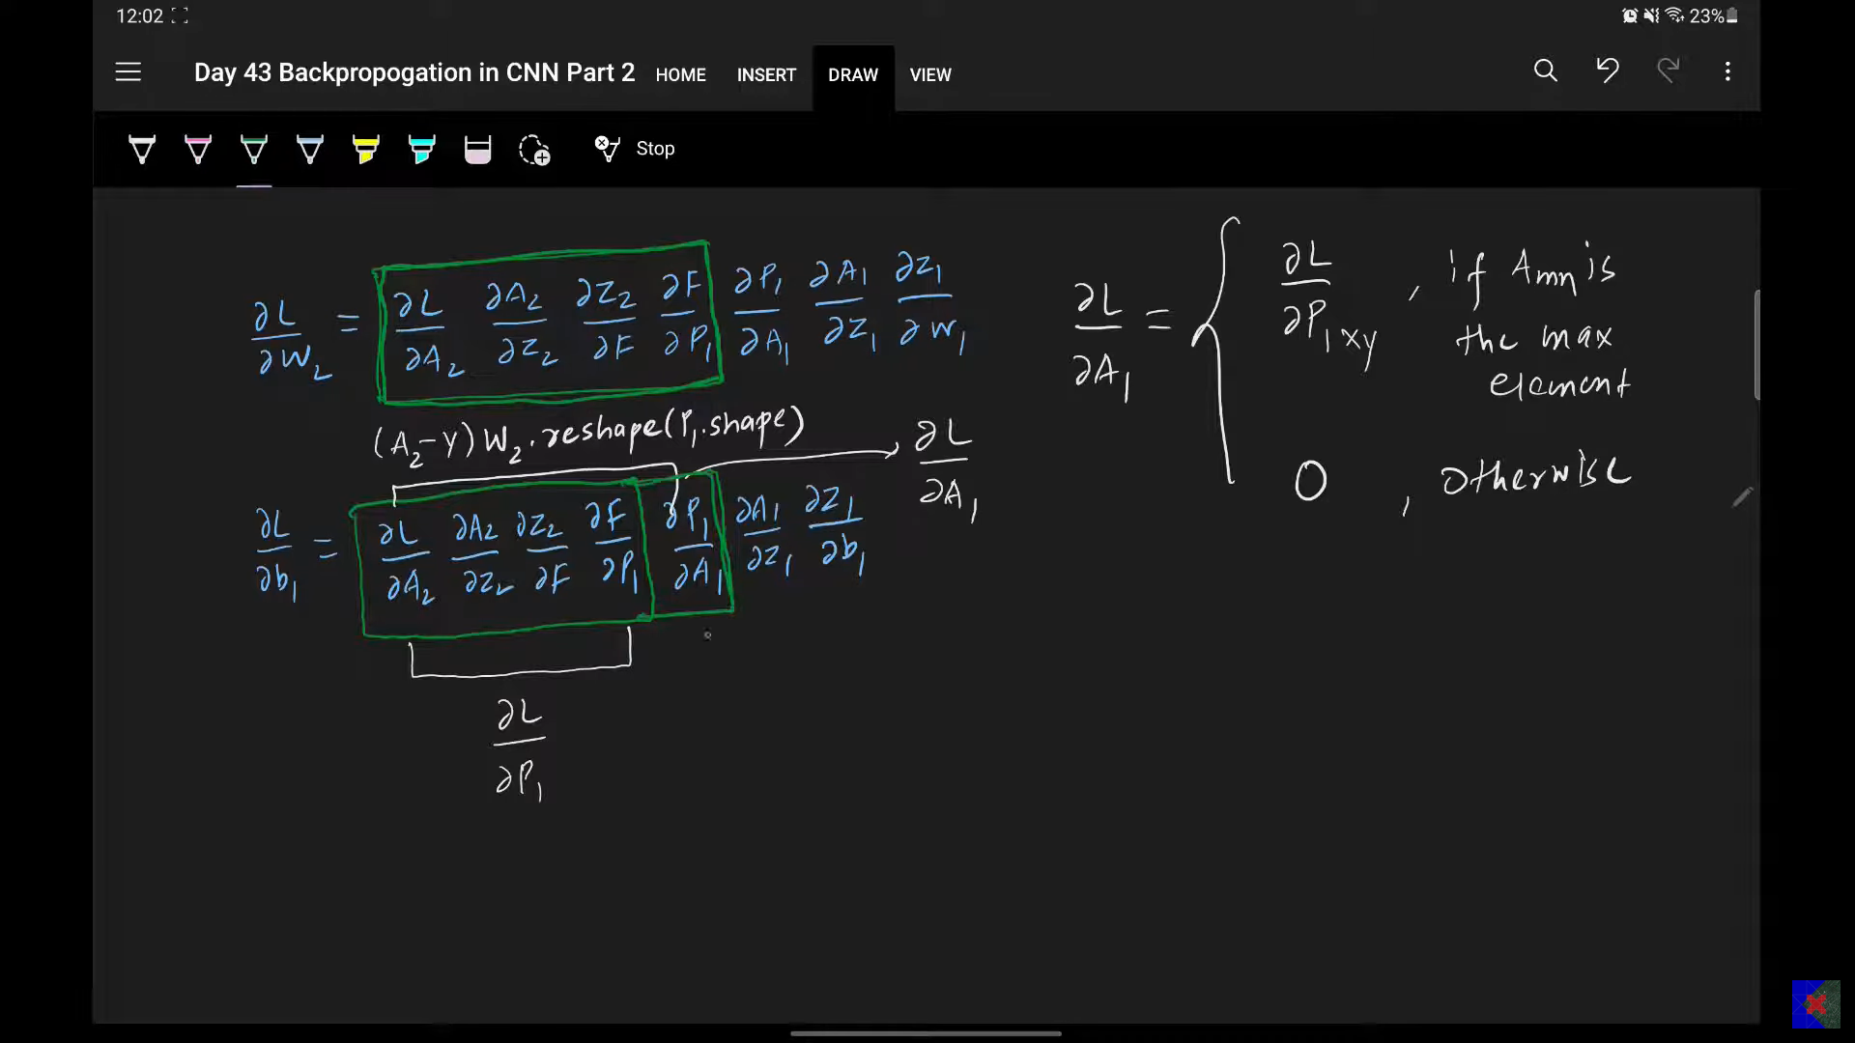

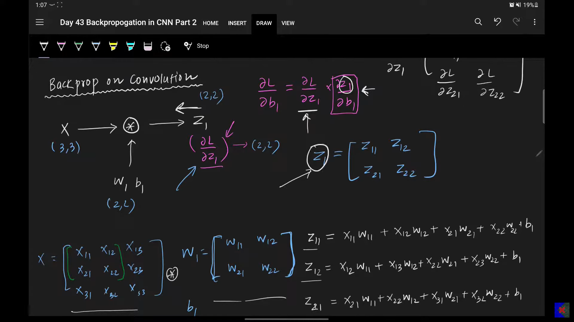

#### **5. Backpropagation on the ReLU Activation Layer**

The ReLU activation function (A1 = ReLU(Z1)) is applied element-wise.

* **Forward Operation:**
  + If Z1_xy > 0, then A1_xy = Z1_xy
  + If Z1_xy <= 0, then A1_xy = 0
* **Backward Operation:** To calculate del L / del Z1, we need del A1 / del Z1.

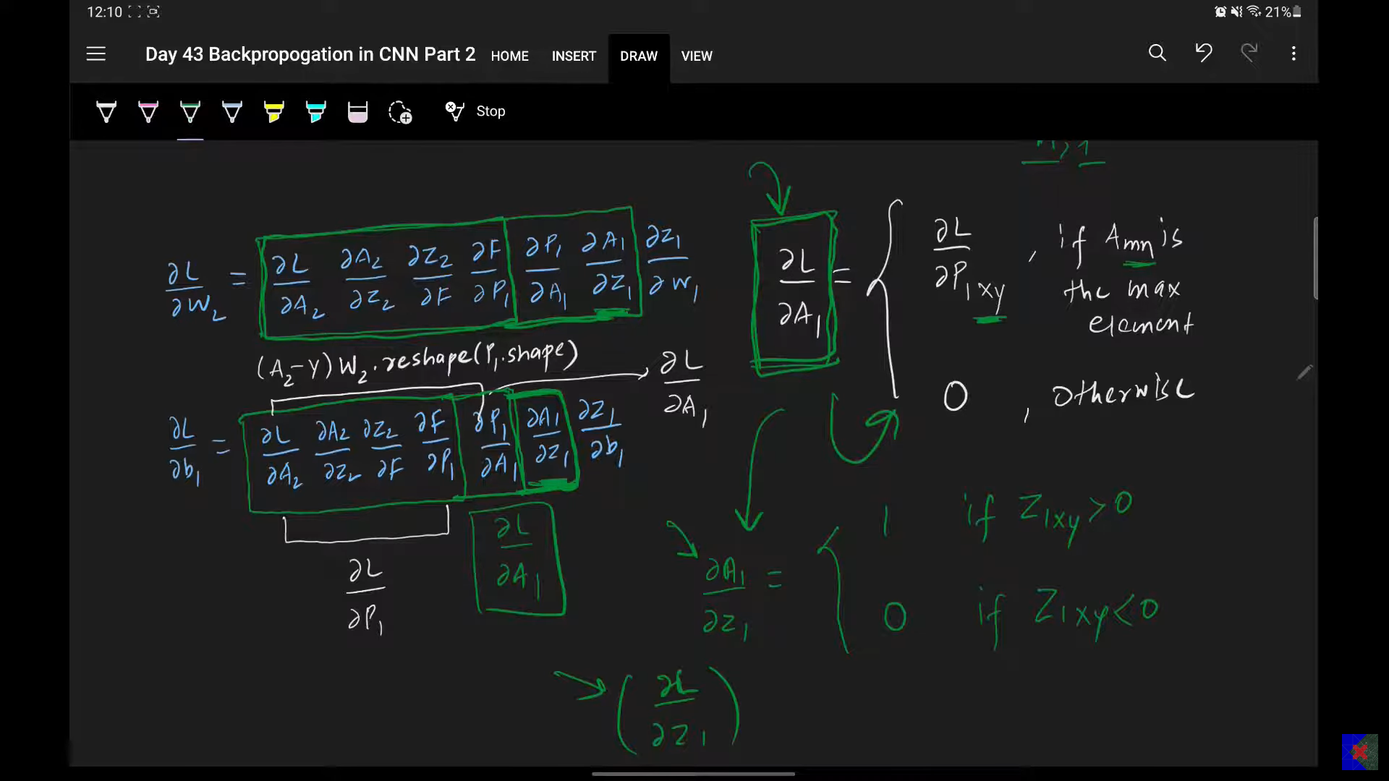

* + The derivative of ReLU is straightforward:
    - If Z1_xy > 0, del A1_xy / del Z1_xy = 1
    - If Z1_xy <= 0, del A1_xy / del Z1_xy = 0
  + Therefore, del L / del Z1 is calculated by **element-wise multiplication** of the incoming gradient del L / del A1 with the derivative of ReLU:
    - del L / del Z1 (x,y) = del L / del A1 (x,y) * 1 if Z1(x,y) > 0
    - del L / del Z1 (x,y) = del L / del A1 (x,y) * 0 if Z1(x,y) <= 0
* **Question:** Why is it important for the ReLU derivative to be 0 for negative inputs during backpropagation?
* **Answer:** Because negative inputs to ReLU resulted in a zero output in the forward pass, they had no influence on the subsequent layers or the final loss. Therefore, no gradient should flow back through those inactive neurons.

#### **6. Backpropagation on the Convolution Layer (Bias B1)**

The convolution layer involves both weights (W1) and biases (B1). We'll first focus on the bias B1 as it is simpler.

* **Simplified Scenario:** Let's assume an input image X is 3x3, and the filter W1 is 2x2. This will produce a Z1 matrix of 2x2.
* **Forward Operation (for Z1 elements):** Each element of Z1 is the result of convolving X with W1 and then **adding the bias B1**. For example, for a 2x2 Z1:  
  + Z1_11 = (convolution_output_at_11) + B1
  + Z1_12 = (convolution_output_at_12) + B1
  + Z1_21 = (convolution_output_at_21) + B1
  + Z1_22 = (convolution_output_at_22) + B1
  + Notice that **B1 is added to every element** of the output feature map.
* **Backward Operation (del L / del B1):**

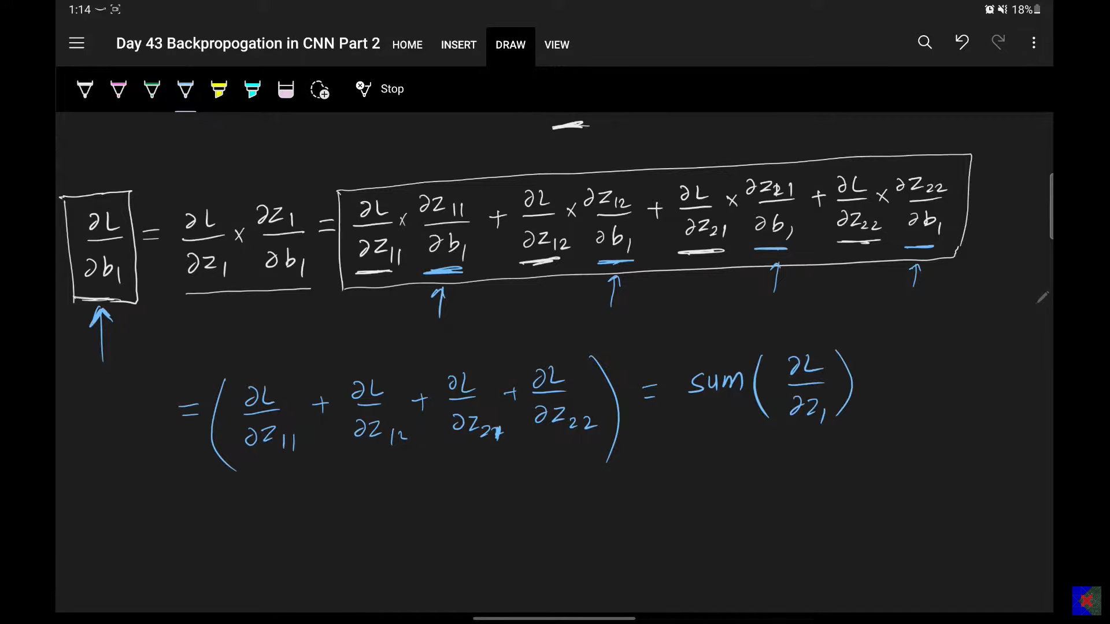

* + Using the chain rule, del L / del B1 involves del L / del Z1 and del Z1 / del B1.
  + Since Z1 is a matrix (e.g., 2x2), del L / del B1 is the sum of (del L / del Z1_ij) * (del Z1_ij / del B1) for all i,j.
  + From the forward operation, del Z1_ij / del B1 = 1 for every element i,j of Z1, because B1 is simply added.
  + Therefore, del L / del B1 is simply the **sum of all elements in the del L / del Z1 matrix**.

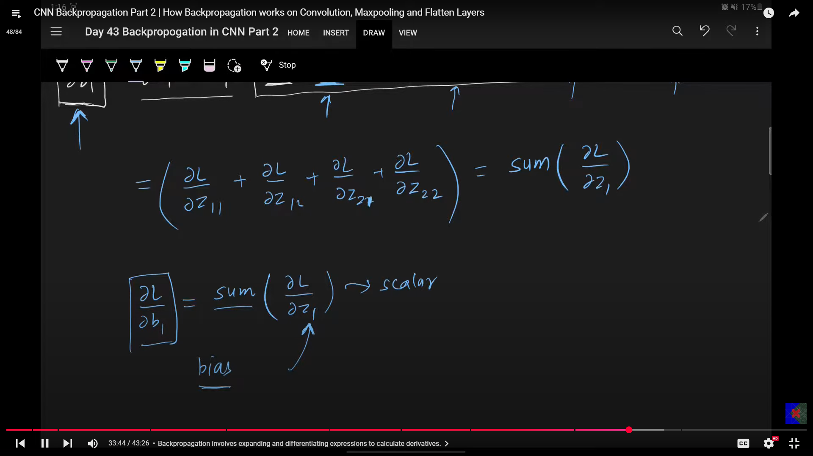

* **Question:** Why does B1 contribute equally to all elements of Z1, and how does this simplify its gradient calculation?
* **Answer:** B1 is a single scalar value added uniformly across the entire output feature map Z1. Because of this uniform addition, its derivative with respect to each element of Z1 is 1, simplifying del L / del B1 to the sum of all incoming gradients to Z1.

#### **7. Backpropagation on the Convolution Layer (Weights W1)**

This is the most complex part of backpropagation in CNNs.

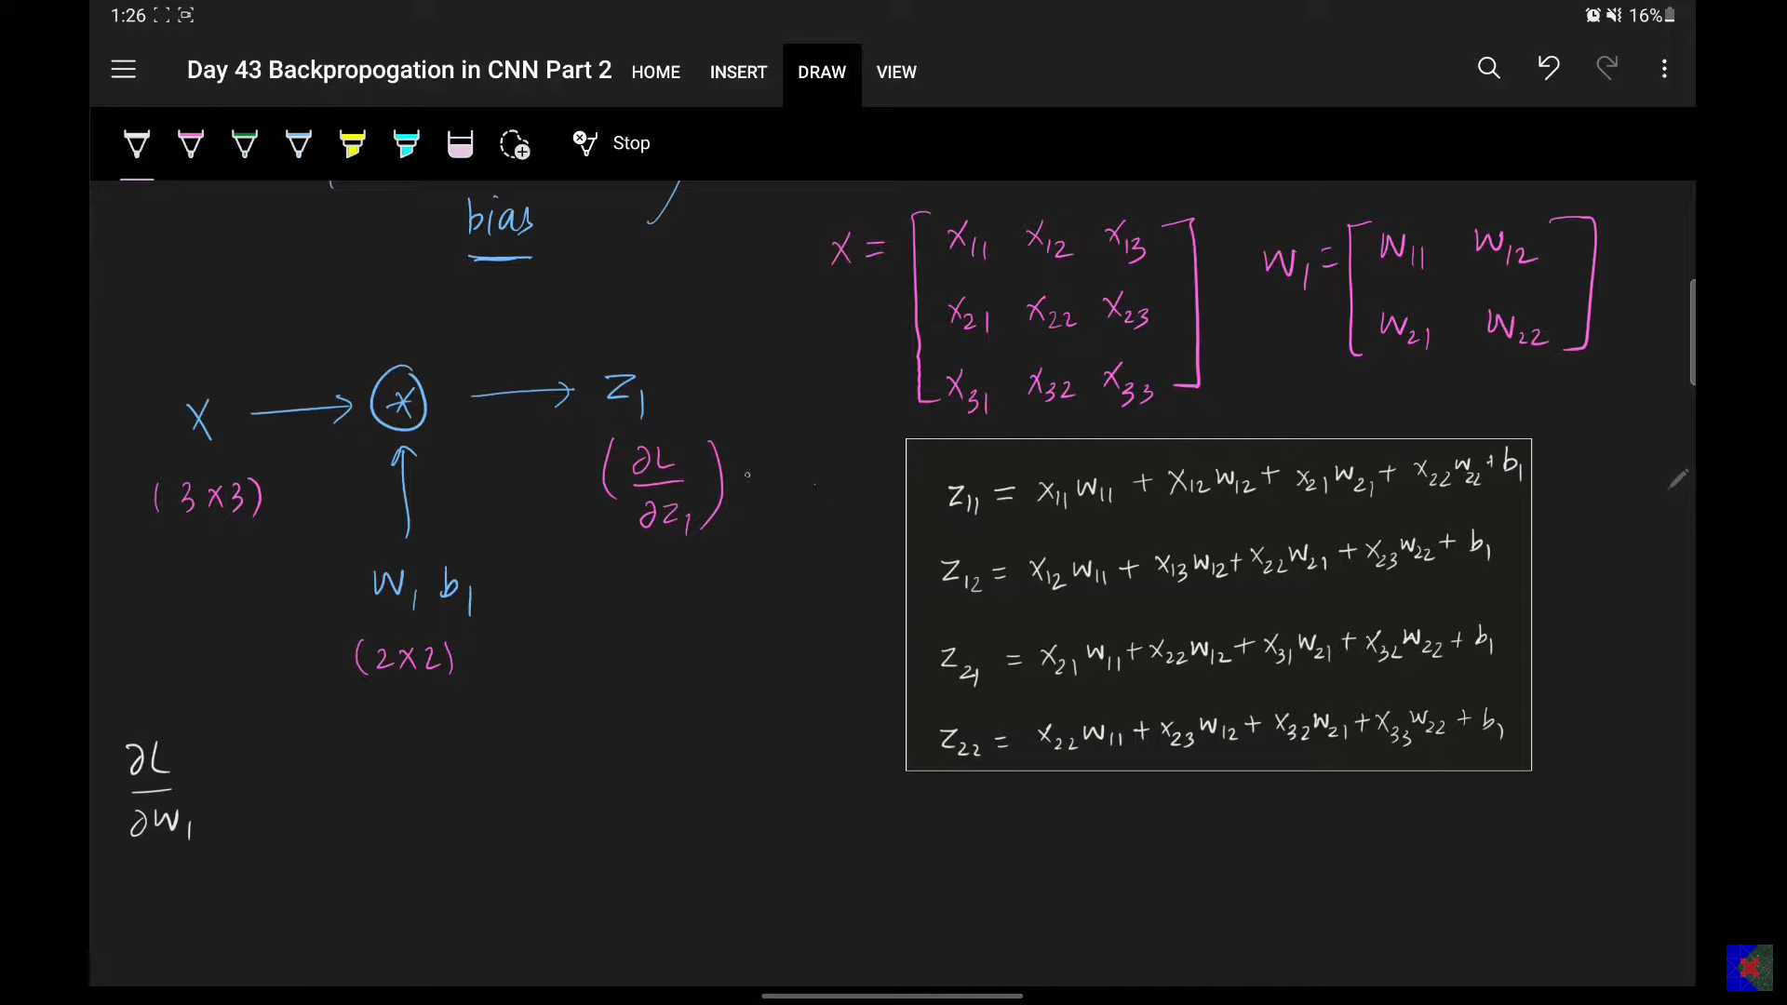

* **Goal:** Calculate del L / del W1.
* **Chain Rule:** del L / del W1 = (del L / del Z1) * (del Z1 / del W1) (where * implies a more complex operation than simple multiplication for matrices).

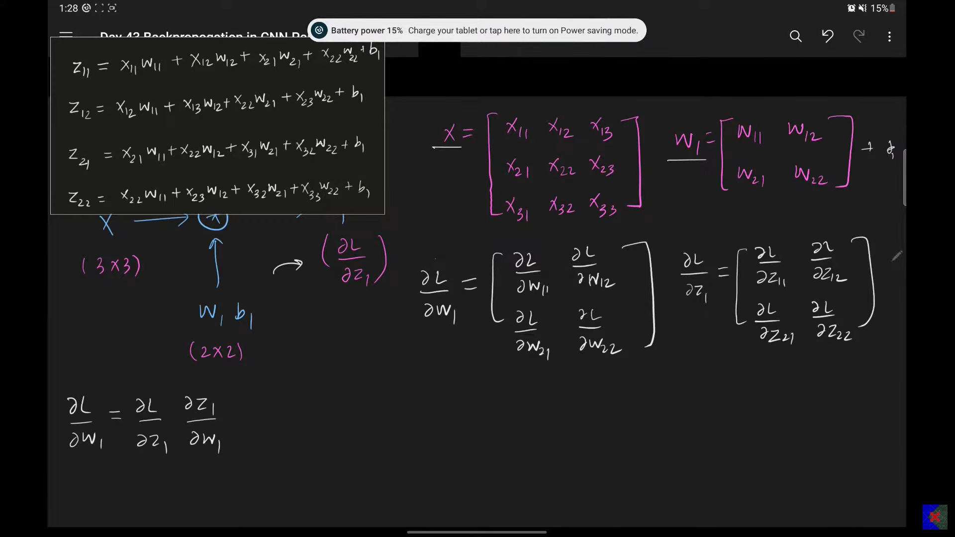

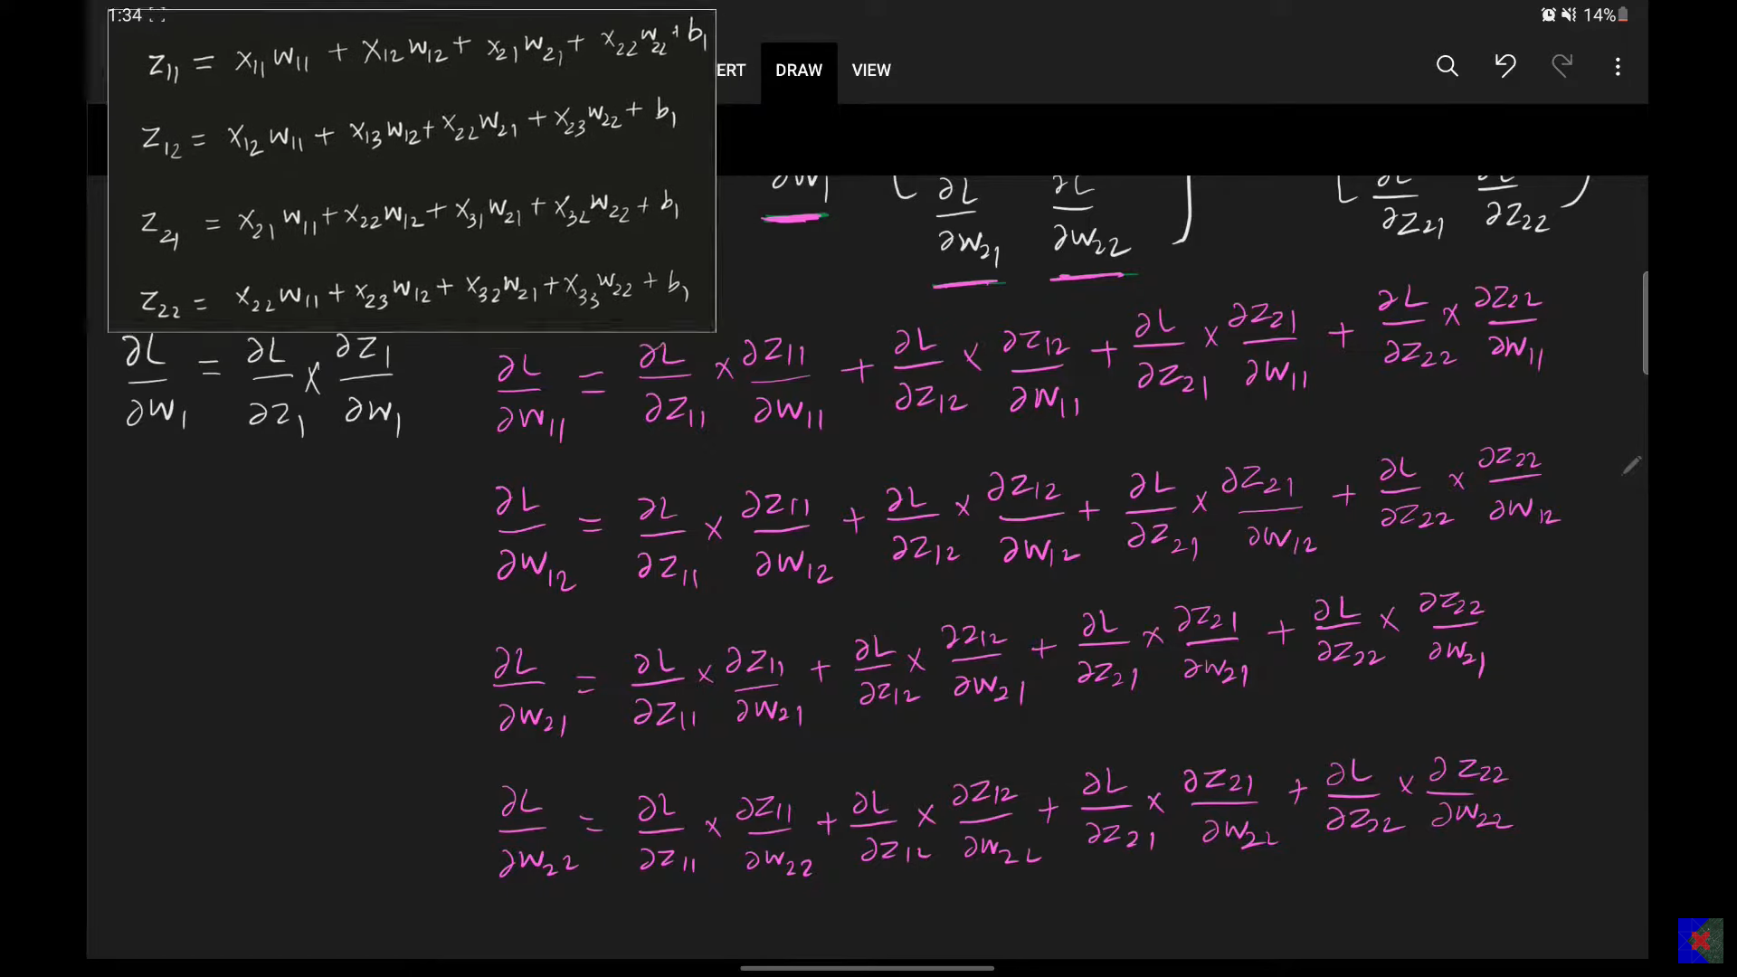

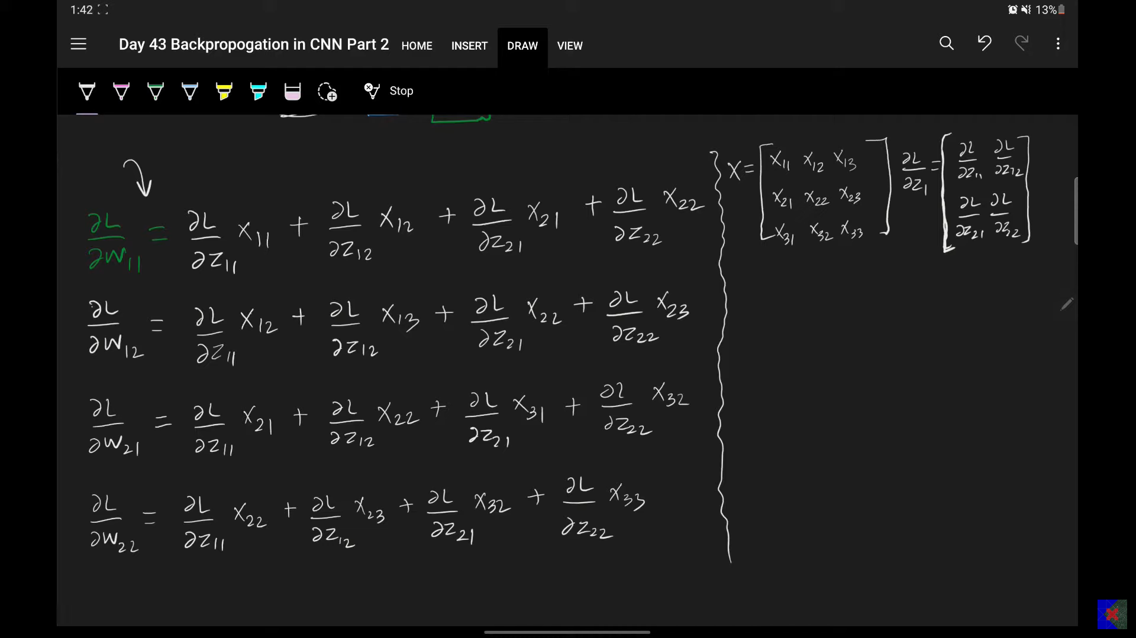

* **Forward Operation (for Z1_ij):** Each element Z1_ij is obtained by convolving the input image X with the filter W1 (and adding B1). This involves element-wise multiplication and summation within a sliding window.  
  + **Example for Z1_11 (with X as 3x3 and W1 as 2x2):**
    - Z1_11 = (X11*W11 + X12*W12 + X21*W13 + X22*W14) + B1
    - (Note: W11, W12, W13, W14 represent the individual elements of the 2x2 filter W1).
  + Similarly for Z1_12, Z1_21, Z1_22, the elements of W1 are multiplied with different elements of X.
* **Backward Operation (del L / del W1):**
  + To find del L / del W1_mn (the gradient for a specific weight W1_mn in the filter), you would sum (del L / del Z1_ij) * (del Z1_ij / del W1_mn) over all i,j.
  + Consider del Z1_11 / del W1_11: from the example above, this would be X11.
  + Consider del Z1_12 / del W1_11: this would be X12 (if W1_11 was multiplied by X12 for Z1_12).
  + This leads to a complex expansion.
* **The Pattern (Reverse Convolution):**

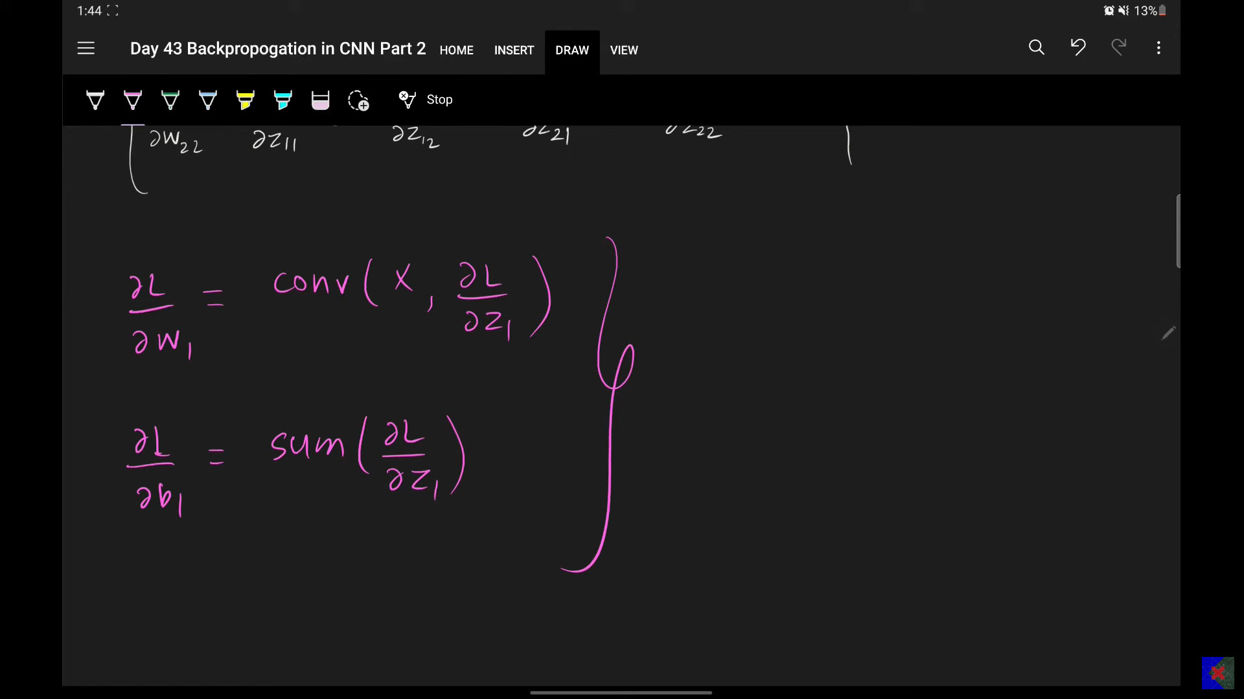

* + The crucial insight is that del L / del W1 is effectively a **convolution operation**.
  + It is calculated by **convolving the input matrix X with the incoming gradient matrix del L / del Z1**.
  + Specifically, del L / del W1 is derived by taking the del L / del Z1 matrix and convolving it with the original input X. This is a "reversed" form of convolution where the del L / del Z1 matrix acts like the filter, and X acts like the input.
* **Question:** How does the "reverse convolution" for del L / del W1 work, and what matrices are involved?
* **Answer:** To calculate del L / del W1, you perform a convolution. The filter in this convolution is the incoming gradient del L / del Z1, and it's convolved across the original input activation map X. The result of this convolution directly gives the gradients for the weights W1.